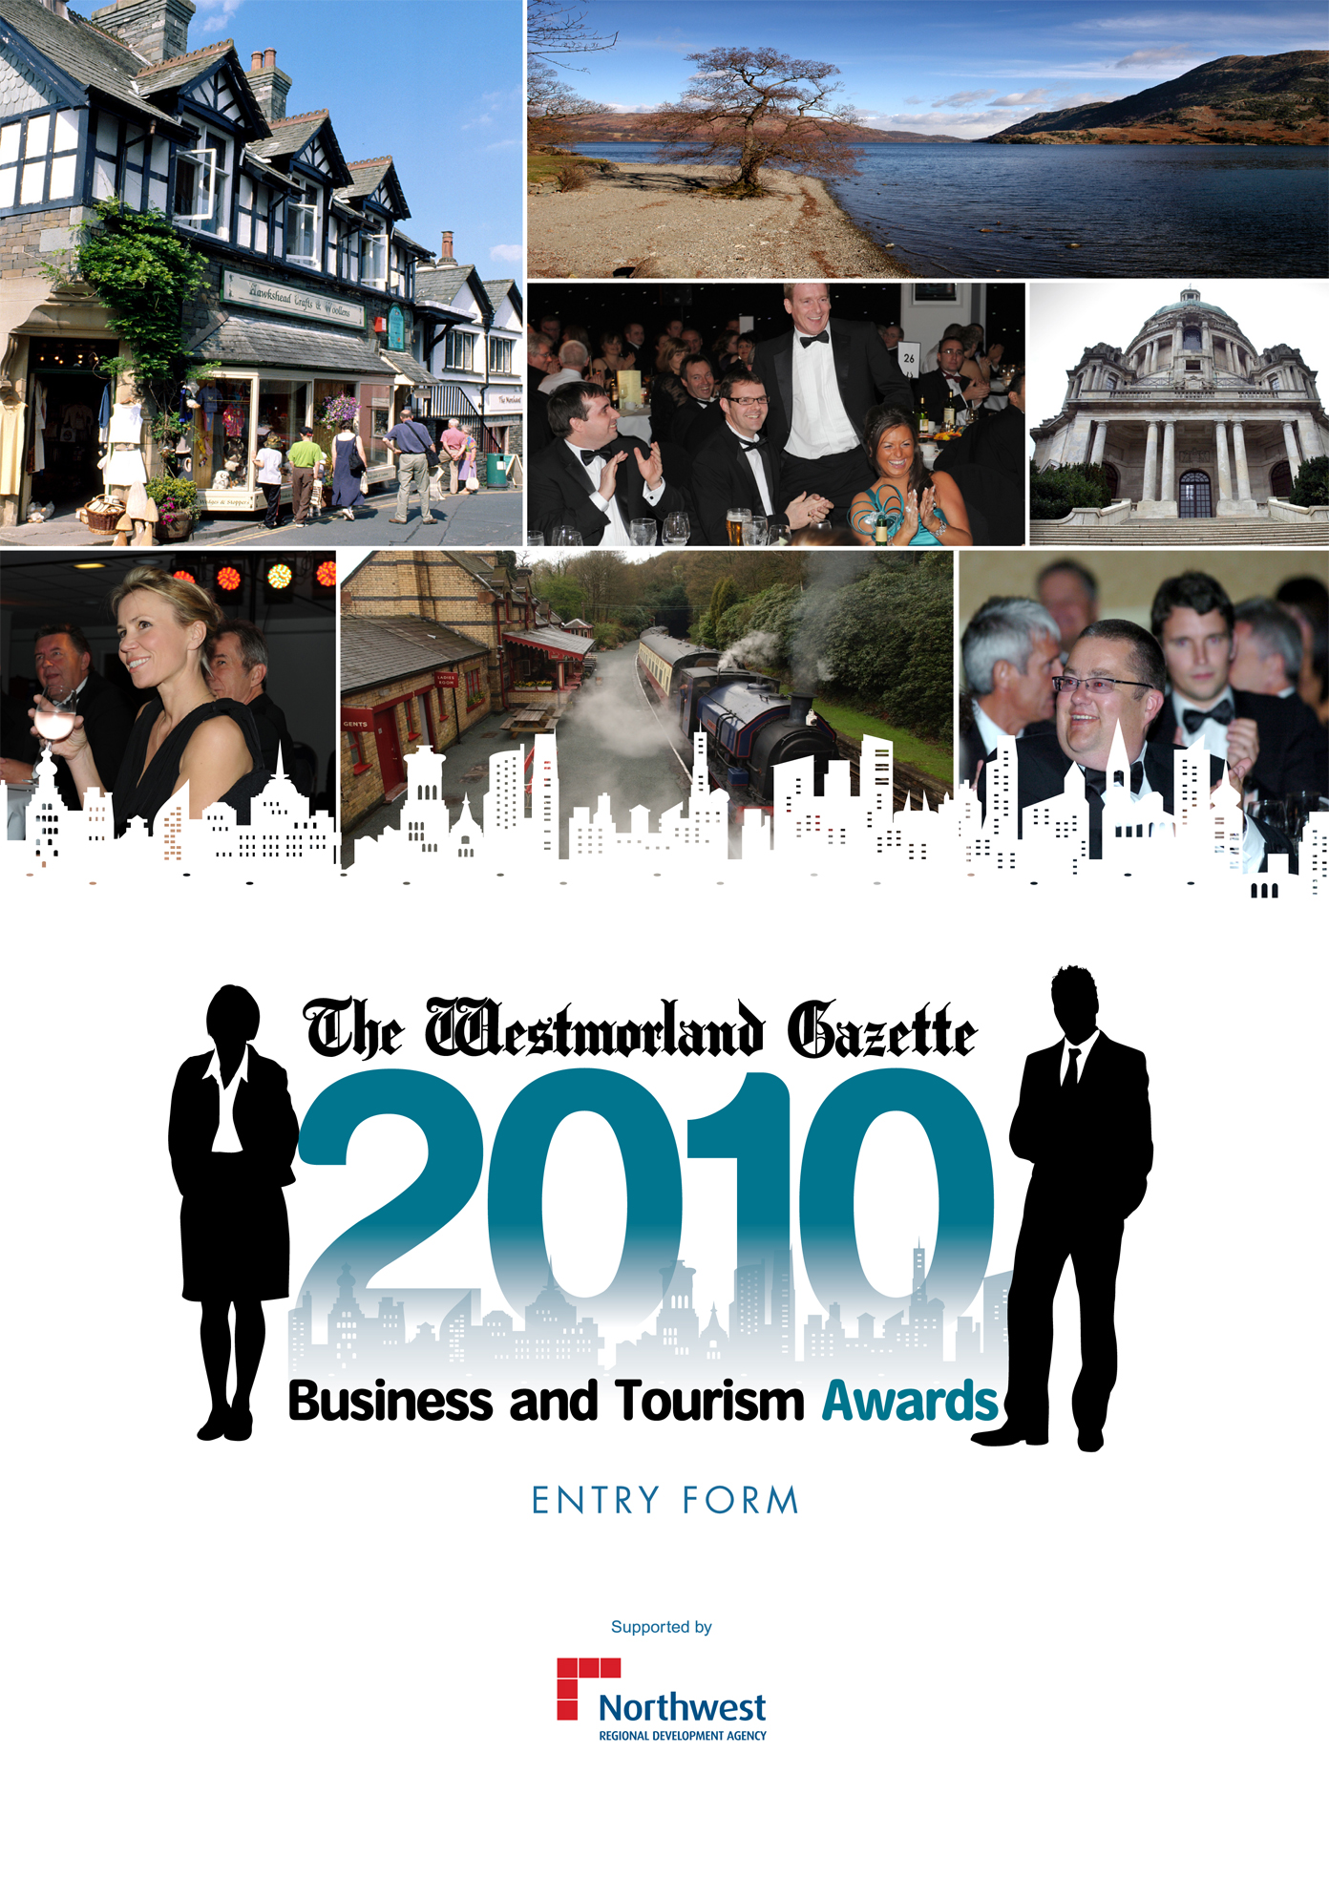
One of the premier events in the Cumbria and North Lancs business calendar has now launched– the Westmorland Gazette Business and Tourism Awards 2010 - in conjunction with the North West Regional Development Agency.
The awards are open to companies of all sizes and we are looking for the businesses or individuals, who through their endeavours, make a vital contribution to the local economy.
There are 11 awards categories covering every facet of business achievement and enterprise. A panel of distinguished judges will choose the overall winners from a shortlist of finalists in each category.
The winners will be announced at a glittering ceremony to be held in The Castle Green Hotel, on Friday, 17th September 2010. We look forward to seeing you there.
If you think your business is THE business,
enter the awards today, you have nothing to
lose and everything to gain by entering an award!

Awards Categories 2010

Business of the Year
This is the premier award in Cumbria and North Lancs business year. Open to any business that can demonstrate a successful track record of excellence and achievement. We are looking for enterprises of any size, working in any sector, including commercial, industrial, agricultural and tourism. The company must demonstrate how it has grown significantly this year and give evidence of employee/employer relations. Your company's success could be measured in exceptional growth, increased trading profit, new product/service development or new production techniques. Since this is THE year's top award you will need to be the best at what you do and be able to demonstrate that in your entry.

Retailer of the Year
Selling directly to the public is a special skill and this award is targeted at businesses of all kinds doing just that. Likely candidates might be specialist retailers with products ordered via the internet, by post, or on the phone. Or they could equally be retailers who have found success by selling through shops, stores or other outlets – in short we are looking for any business that has become a winner by selling people what they want, when and how they want it. You could be a firm with just two or three employees or many more. Consideration will be given to customer service excellence, proven success within your marketplace, successful marketing initiatives and results achieved. The winner of this award will be able to demonstrate how it stays ahead of the competition.

Training and Development Award
Good quality training is the key to success for any business. Employee’s who know what to do, and the safest and most efficient ways to do it, are the cornerstone of a successful enterprise. This award recognizes companies who are committed to recruiting local people from a variety of backgrounds, overcoming inequality and developing and supporting their workforce. The winner of this award will be any business in any sector that can demonstrate the benefits to their organisation, what results were achieved and why this is an example of exceptionally effective training and development.

Small Business of the Year
Launching your own business requires a whole range of skills and qualities and this award is designed to recognise and celebrate them. You might be a manufacturer establishing a market, a business providing a service, or an enterprise involved in tourism or agriculture. We are looking for small businesses striving for success in any sector. Innovation, expertise and imagination are just some of the qualities that will help firms qualify for this award.

Innovation and Technology – Sponsored By

An innovative attitude is the key to this category, which is for businesses that have shown pioneering spirit to achieve success. Applications will be accepted from all kinds of businesses, whether large companies or small independent workshops. Ingenuity, determination and talent are the key qualities we are looking for and use of innovation or application of technology. The winner might have designed and launched an innovative product, process or scheme to become a leader in its particular field, or harnessed groundbreaking technology.

Team of the Year
This award is every business’s opportunity to put forward a team of people who have really made a difference. Their impact might have been an ability to bring new solutions to an old problem and benefit the way an enterprise works, or a fantastic performance in production, sales or another discipline. Equally it might be a group, or complete workforce, who have brought a new meaning to the term Customer Service, or whose attitude and example stimulates others. In brief it’s your chance to put your heroic employees into the spotlight they deserve.

Bed and Breakfast of the Year – Sponsored By

Bed and Breakfast providers are the corner stone of the tourism industry in our area, and this award celebrates the efforts of those who provide the kind of top quality hospitality, which makes visitors come back again and again. The size of the accommodation is not as important as the warmth of the welcome and quality of service offered to tourists from home and abroad.

Hotel of the Year
Hotels come in all shapes and sizes and this award recognises the cream of the crop. The key to a good hotel is its staff, knowing what their guests want and work hard to make sure that expectations are exceeded. Food, bedrooms, bars and dining rooms are all important and so are those extra special facilities. But quality of service is key to any successful hotel and this means having staff equipped to meet every need in an atmosphere where people can relax, unwind and enjoy a hard-earned holiday.

Tourist attraction/Tour Operator of the Year
The natural beauty of our region makes it a ‘must see’ destination for many tourists, but once they are here people want to enjoy exploring the many and varied attractions that will make their visit a memorable one. This award recognizes the many enterprises that have been developed to make holidays complete, or the tour operators who show groups of different aspects of our countryside and lakes, even introducing them to the activities that can take place here. Size doesn’t matter so much as the quality of experience offered to tourists.

Green Business Award
This category is for any enterprise that has taken positive action to demonstrate an awareness of green issues. It could be that you have introduced processes, which will result in a genuine improvement to the environment, or have by a series of measures made a real difference to the local or national environment. Alternatively, it could be a business that has ‘gone green’, by introducing systems or initiatives within its own business that demonstrate it is truly environmentally aware, or has embarked on an education exercise to spread the word to others.

Social & Community Development
This award is all about real action, either by enterprises putting something back into the communities in which they operate, or businesses in which the bottom line isn’t the driving factor, but which carry out work to benefit individuals in our region. It is open to charities and all kinds of social enterprises as well as conventional companies. The latter might have allowed community organizations, schools or charities to use the resources of the business or given them ideas, advice, money or expertise.
Application Form

Full name of applicant Email Address

Position held Contact name if different to applicant

Name of company / organisation Telephone

Address Fax

Post Code Date Founded

Number of employees Financial year end (dd/MM/YYY)

Please submit the relevant financial information about your business. Further financial information may be requested by our judging panel.

(Please attach or enclose any information you feel may support your award)

Company or individual details / performance – General description of the business and financial Performance – Please forward audited accounts if possible.

Most recent year: | Turnover | Gross Profit | Pre-tax profit | Net worth | Number of staff

Previous year: | Turnover | Gross Profit | Pre-tax profit | Net worth | Number of staff

Year before that: | Turnover | Gross Profit | Pre-tax profit | Net worth | Number of staff

Please tick the category or categories you would like to enter

Business of the Year □

Retailer of the Year □

Training & Development Award □

Small Business of the Year □

Innovation & Technology □

Team of the Year □

Bed & Breakfast of the Year □

Hotel of the Year □

Tourist attraction/Tour Operator of the Year □

Green Business Award □

Social & Community Development □

All entries will be considered for Business of the Year

Please complete the relevant information for your award. Please note that the more information you provide the more support you give to your awards entry.

Location - Main location of business and any trading subsidiaries

History - Brief history, why it was set up and synopsis of its development

Ownership / Management – Give details of principal directors / managers

Products / Services – Give details of your products or service and what makes them different

Future plans – Provide brief details of your plans to exploit the opportunities within the market

Training / personal achievement – Please provide details of any initiatives for staff training for either individuals or groups or information about personal achievements during the past 12 months which have proved to be a major benefit to the business.

Your reason for entry – Please tell the judges why your company or particular individual, should win this award.

Declaration

I confirm that the information contained in this entry form is accurate. I agree to abide by the rules of the competition and accept the judges’ decision as final.

Name of company:

Name of person completing the application:

Position:

Date:

Director’s approval for submission:

Signature:

Return to:-
Westmorland Gazette Business and Tourism Awards, Editorial, Westmorland Gazette, 1 Wainwright’s Yard, Kendal, LA9 4DP or email businessawards@kendal.newsquest.co.uk

Closing date Monday 12th July 2010

Please ensure that any supporting information is attached.

Conditions of entry

- All entries must be from businesses/organisations operating within the distribution area of the Westmorland Gazette.
- The information provided on the entry form must be accurate. The panel of judges may request further supporting information, if required. In the event of any evidence arising, which contradicts earlier claims, the judges reserve the right to withdraw the award at a later date.
- Information supplied (other than financial) on or with the entry form may be used in The Westmorland Gazette and associated publications. However, any information clearly marked as confidential will be treated in the strictest possible confidence and will not be used in any publicity.
- The decision of the organisers, sponsors, or any of the judges, is final in respect of all matters concerning these awards, including the interpretation of these rules. The organisers have the right to reallocate an entry if they feel it has more opportunity to win in another category.
- All entrants will be expected to co-operate with the publicity surrounding the awards should their entry prove successful.
- All entries must be received by the organisers by the closing date on Monday, July 19th, 2010.
- Proof of posting cannot be accepted as proof of delivery for the purpose of the competition. All the entries and supporting material will be sent at the entrant's own risk.
- All entrants must fill in the confirmation section at the end of the entry form, acknowledging that they have read and understood all the rules and regulations of the competition.
- Participation in The Westmorland Gazette Business and Tourism Awards 2010 means acceptance of these rules and regulations.
- An independent panel of will judge the entries. The Judges’ decision is final and no correspondence will be entered into.
- Shortlisted nominees will be invited to the Gala Awards dinner at The Castle Green Hotel, Kendal on Friday, September 17, 2010.

